A PROJECT REPORT

on

### DESIGN OF CMOS PLL FOR LOW FREQUENCY APPLICATION

Submitted in partial fulfillment of the requirements for the award of the degree of

### Bachelor of Technology

##### in

**Electronics & Communication Engineering**

Submitted by

**Chandra Prakash(2215000512)**

**Nirpesh Chaudhary (2213000007)**

**Lacky Chaudhary(2213100009)**

**Akash Chaudhary(2215000148)**

**Under the supervision of**

**[Dr.Shelesh Krishna Saraswat]**



Department of Electronics & Communication Engineering Institute of Engineering & Technology

GLA University, Mathura-281406, India

December, 2024

### DECLARATION

We hereby declare that this submission is our own work and that, to the best of our knowledge and belief, it contains no material previously published or written by another person nor material which to a substantial extent has been accepted for the award of any other degree or diploma of the university or other institute of higher learning, except where due acknowledgment has been made in the text.

|  |  |  |  |
| --- | --- | --- | --- |
| Signature:  Name: | [Chandra Prakash] | [Nirpesh Chaudhary] | [Akash Chaudhary] [Lacky Chaudhary] |
| Roll No | (2215000512) | (2213000007) | (2215000148) (2213100009) |
| Date: |  |  |  |

### CERTIFICATE

This is to certify that the Project Report entitled, “Lora-based IOT Smart Agriculture Monitoring & Automatic Systems” which is being submitted by Nirpesh Chaudhary, Chandra Prakash ,Akash Chaudhary and Lacky Chaudhary .in partial fulfillment of the requirement for the award of degree B.Tech in Electronics & Communication Engineering and submitted to the Department of Electronics & Communication Engineering of GLA University, is a record of the candidate own work carried out by him/her under my supervision. The matter embodied in this report is original and has not been submitted for the award of any other degree.

Date: Dr. Shelesh Krishna Saraswat

(Assistant Professor)

iii

### ACKNOWLEDGEMENTS

It gives us a great sense of pleasure to present the report of the B. Tech Project undertaken during B.Tech III Year. We owe a special debt of gratitude to (Dr. Shelesh Krishna Saraswat , Assistant Professor), Department of Electronics & Communication Engineering, GLA University, Mathura for his constant support and guidance throughout the course of our work. His sincerity, thoroughness, and perseverance have been a constant source of inspiration for us. It is only his cognizant efforts that our endeavors have seen the light of the day.

We also take the opportunity to acknowledge the contribution of Prof. V.K Deolia, Head, Department of Electronics & Communication Engineering, GLA University, Mathura for his full support and assistance during the development of the project.

We also do not like to miss the opportunity to acknowledge the contribution of all faculty members of the department for their kind assistance and cooperation during the development of our project. Last but not least, we acknowledge our friends for their contribution to the completion of the project

### ABSTRACT

The project proposes a LoRa-based IoT Smart Agriculture Monitoring and Automatic System to enhance crop yields, reduce water consumption, and promote sustainable agriculture practices. The system integrates LoRaWAN technology with sensors, automation controllers, and a cloud-based platform to provide real-time monitoring and control of agricultural parameters such as soil moisture, temperature, humidity, and light intensity.

The system consists of a LoRaWAN gateway, sensor nodes, automation controllers, and a cloud-based platform. The sensor nodes collect data from the field and transmit it to the LoRaWAN gateway, which forwards the data to the cloud-based platform. The platform analyzes the data and sends control signals to the automation controllers to adjust irrigation, fertilization, and pest control systems.

The system aims to:

1. Monitor soil moisture, temperature, humidity, and light intensity in real-time.

2. Automate irrigation, fertilization, and pest control systems based on sensor data.

3. Provide real-time alerts and notifications to farmers via mobile app.

4. Analyze data to optimize crop yields, reduce water consumption, and promote sustainable agriculture practices.

The proposed system has the potential to revolutionize agriculture by providing farmers with real-time insights and automated control over agricultural parameters, leading to increased crop yields, reduced water consumption, and improved sustainability.

**TABLE OF CONTENTS** Page

DECLARATION ................................................................................................... ii

CERTIFICATE ..................................................................................................... iii

ACKNOWLEDGEMENTS .................................................................................. iv

ABSTRACT ........................................................................................................... v

LIST OF TABLES……………………………………………………………….. ix

LIST OF FIGURES……………………………………………………………….. x

CHAPTER 1 INTRODUCTION AND BACKGROUND.

* + 1. 1.1 Background
    2. 1.2 Problem Statement
    3. 1.3 Research Questions
    4. 1.4 Objectives
    5. 1.5 Scope
    6. 1.6 Significance of the Study

CHAPTER 2 Literature Review

2.1 Overview of IoT in Agriculture

2.2 LoRaWAN Technology

2.3 Smart Agriculture Monitoring Systems

2.4 Automatic Irrigation Systems

2.5 Related Works

CHAPTER 3 DESIGN AND IMPLEMENTATION

3.1 System Architecture

3.2 Hardware Components

3.3 Software Components

3.4 System Design Methodology

3.5 Experimental Design

SIMULATION AND

* 1. Simulation setup 17
     1. Tools Used
     2. Test Conditions
  2. PFD Simulation Analysis 17
     1. Performance Metrics
     2. Graphical Results
  3. CP Simulation Analysis 17
     1. Performance Metrics
     2. Graphical Results
  4. Integrated PLL Simulation 18
     1. Locking Performance
     2. Phase Noise and Jitter
     3. Graphical Results

CHAPTER 5 CHALLENGES AND OPTIMIZATION

* 1. Challenges in Low Frequency PLL Design 19
     1. Components specific challenges
     2. System Level Challenges
  2. Proposed Optimizations 20
     1. Circuit level Improvements
     2. System level Enhancements

CHAPTER 6 APPLICATIONS AND FUTURE SCOPE

* 1. Applications of Low Frequency PLL 21
     1. Communication Systems
     2. Audio Processing
     3. Industrial Control
  2. Future Scope 21
     1. Advanced CMOS Technologies
     2. Integration with Emerging Technologies
     3. Extension to other frequencies

CHAPTER 7 (CONCLUSIONS) 23

REFERENCES 24

# LIST OF TABLES

Table 1: Design and Simulation Steps for Lora based technology

# LIST OF FIGURES

Figure 1: System Architecture

Figure 2: Sensor NodHardware

Figure 3: LoraWAN Topology

Figure 4: Cloud based Architecure

Figure 5: Mobile Applications UserInterface

Figure 6: System Development

Figure 7: Soil Moisture Sensor Caliboration Curve

x

# CHAPTER 1: INTRODUCTION AND BACKGROUND

#### Introduction

##### Introduction to Lora-based IOT Smart Agriculture Monitoring &Automatic System

Agriculture is the backbone of many economies around the world, providing food, employment, and income for millions of people. However, agricultural productivity is facing significant challenges due to factors such as climate change, soil degradation, and water scarcity. To address these challenges, there is a growing need for innovative technologies that can improve agricultural productivity, reduce waste, and promote sustainable practices.

##### Importance of Lora based IOT smart agriculture monitoring & automatic system

The proposed LoRa-based IoT Smart Agriculture Monitoring and Automatic System has significant importance in the agriculture sector. Here are some of the key reasons:

1. Improved Crop Yields: The system enables farmers to monitor and control agricultural parameters in real-time, leading to improved crop yields and reduced waste.

2. Water Conservation: The system's automated irrigation control feature helps conserve water by optimizing irrigation schedules and reducing water waste.

3. Reduced Energy Consumption: The system's energy-efficient design and LoRaWAN technology reduce energy consumption, leading to cost savings for farmers.

4. Increased Efficiency: The system automates many agricultural tasks, freeing up farmers' time to focus on other important tasks.

#### Background of the Problem

##### Challenges in Low-Frequency CMOS PLL Design

Designing CMOS PLLs for low-frequency applications involves unique challenges, such as maintaining high accuracy in phase detection and charge pump operation while minimizing power consumption. The design must also account for noise, jitter, and other non-idealities that can degrade performance. Achieving a balance between stability, speed, and power efficiency is critical in these designs.

##### CMOS Technology in PLLs

CMOS technology offers several benefits for PLL design:

Low Power Consumption: Essential for battery-operated and portable devices.

High Integration: Enables integration of PLLs with other system components on a single chip.

Scalability: Facilitates the design of smaller and more efficient systems as technology advances.

Cost-Effectiveness: Mass production of CMOS-based circuits is economical compared to other technologies.

These advantages make CMOS an attractive choice for low-frequency PLL applications where performance and efficiency are paramount.

#### Statement of the Problem

##### Core Problem

The specific problem addressed in this report is the design and simulation of efficient Phase Frequency Detector (PFD) and Charge Pump (CP) circuits for low-frequency CMOS PLLs. These components are critical to the PLL’s overall performance.

##### Importance of Accurate PFD and CP Designs

The PFD and CP are key contributors to the PLL's performance. The PFD determines the phase error between the input and output signals, while the CP converts this phase error into a control signal for the voltage-controlled oscillator (VCO). Inefficiencies or inaccuracies in these components can lead to increased phase noise, jitter, and instability, thereby degrading the PLL’s performance.

#### Objectives and Scope of the Project

##### Main Objective

The primary objective of this report is to design, simulate, and analyze the PFD and CP circuits for a CMOS-based PLL optimized for low-frequency applications. The report demonstrates the individual performance of these components and their combined behavior in a simulated environment.

##### Scope

In-Scope: The focus is on the design and simulation of the PFD and CP, including schematic development and performance evaluation. Integration of these components and their combined performance are also included.

Out-of-Scope: The design and analysis of the VCO and loop filter are outside the scope of this report. However, their integration within a complete PLL system is briefly discussed for context.

#### Significance of Study

##### Contribution to Low-Frequency PLL Designs

This work contributes to improving the performance of CMOS PLLs in low-frequency applications by providing optimized designs for the PFD and CP. These designs aim to achieve high accuracy, low power consumption, and robust performance, addressing key challenges in low-frequency PLL implementation.

##### Real-World Applications

The findings of this study are applicable to a wide range of low-frequency systems, including communication devices, audio processing systems, and industrial control systems, where stable and precise frequency control is critical.

#### Overview of CMOS Technology in PLL Design

##### CMOS Benefits

CMOS technology is widely used in PLL design due to its:

Low Power Consumption: Suitable for low-frequency, energy-efficient systems. High Integration Density: Enables compact and integrated designs.

Cost-Effectiveness: Reduces production costs, making CMOS designs viable for mass production.

##### Design Considerations in CMOS PLLs

Key considerations in CMOS PLL design include:

Noise Performance: Minimizing phase noise and ensuring signal fidelity. Jitter Reduction: Enhancing the timing accuracy of the system.

Precision in PFD and CP: Designing these components to achieve accurate phase detection and efficient charge transfer, crucial for the overall performance of the PLL.

These considerations highlight the trade-offs in achieving an optimal balance between performance, power, and cost.

# CHAPTER 2: CMOS PLL ARCHITECTURE AND COMPONENTS

#### Overview of CMOS PLL Architecture

##### PLL

The core architecture of a Phase-Locked Loop (PLL) consists of the following components:

**Phase Frequency Detector (PFD):** Compares the phase and frequency of the input and feedback signals.

**Charge Pump (CP):** Converts the PFD output into a control voltage.

**Voltage-Controlled Oscillator (VCO):** Generates a frequency-controlled output signal. Loop Filter: Smoothens the control voltage, removing noise and stabilizing the system. **Feedback Divider:** Divides the output frequency to match the reference signal for synchronization.

The interaction between these blocks ensures the PLL maintains phase and frequency synchronization between the input and output signals.

##### Functional Overview

The PFD detects the phase and frequency differences between the reference input and feedback signal.

The CP adjusts the control voltage proportional to the PFD output, driving the VCO. The VCO generates an oscillatory output with a frequency proportional to the control voltage.

The Loop Filter stabilizes the control voltage, ensuring consistent VCO operation. The Feedback Divider ensures the VCO frequency aligns with the reference signal frequency, closing the feedback loop.

#### Phase Frequency Detector (PFD)

##### Purpose of PFD

The PFD is responsible for detecting phase and frequency mismatches between the reference signal and the feedback signal. It generates "up" or "down" signals that control the charge pump, facilitating adjustments to minimize phase and frequency differences.

#### Types of PFD

XOR-Based PFD:

Simple in design but has a limited range and suffers from dead zone issues, reducing its suitability for precise applications.

JK Flip-Flop-Based PFD:

Offers improved phase detection with better stability but may be slower in operation. D-Flip-Flop-Based PFD:

Widely used in CMOS PLLs due to its high accuracy and robustness. This design eliminates dead zones by using two D flip-flops configured with reset logic to ensure proper operation. It is particularly well-suited for low-frequency applications, offering excellent performance with minimal complexity.

#### Design Considerations

Speed: The PFD must operate at sufficient speed to handle changes in input frequency and ensure timely corrections.

Accuracy: Designs employing D flip-flops minimize dead zones, improving phase detection precision and ensuring better system stability.

Power Consumption: CMOS-based PFD designs are optimized for low power, ensuring efficiency for battery-operated and portable devices.

By using a D-flip-flop-based design, the PFD achieves a balance of simplicity, accuracy, and energy efficiency, making it a cornerstone of CMOS PLLs for low-frequency applications.

#### Charge Pump

##### Role of CP

The PFD is responsible for detecting phase and frequency mismatches between the reference signal and the feedback signal. It generates "up" or "down" signals that control the charge pump, facilitating adjustments to minimize phase and frequency differences.

#### Key Design Challenges

Charge Sharing: Leads to voltage inconsistencies, reducing loop stability.

Current Mismatch: Causes distortion in the control voltage, affecting VCO performance. Low-Frequency Noise: Introduces jitter and phase noise, which degrade PLL accuracy. Efforts to mitigate these issues involve advanced circuit design techniques, including differential charge pumps and optimized current mirrors.

#### Voltage Controlled Oscillator

##### Role in PLL

The VCO is the primary signal generator in the PLL, producing an output whose frequency is directly controlled by the input voltage from the CP.

##### CMOS VCO Design Techniques Ring Oscillators:

* + - * Simple to implement and suitable for CMOS processes.
      * High integration density but suffers from higher phase noise.

##### LC Oscillators:

* + - * Provide superior phase noise performance, suitable for high-precision applications.
      * More complex and require larger chip area.
      * For low-frequency CMOS PLLs, ring oscillators are often preferred due to their compactness and energy efficiency.

#### Loop Filter

##### Purpose of Loop Filter

The loop filter stabilizes the control voltage output from the charge pump by removing high-frequency noise and smoothing transitions. This stabilization ensures reliable VCO performance and loop stability.

##### Types of Loop Filters Passive Loop Filters:

* + - * Use resistors and capacitors for simplicity and low power consumption.
      * Suitable for low-frequency applications but may have limited noise suppression.

##### Active Loop Filters:

* + - * Include operational amplifiers for improved noise filtering and dynamic range.
      * More complex and power-intensive, making them less ideal for low-power designs.

Choosing the appropriate filter type depends on the specific performance requirements of the PLL system.

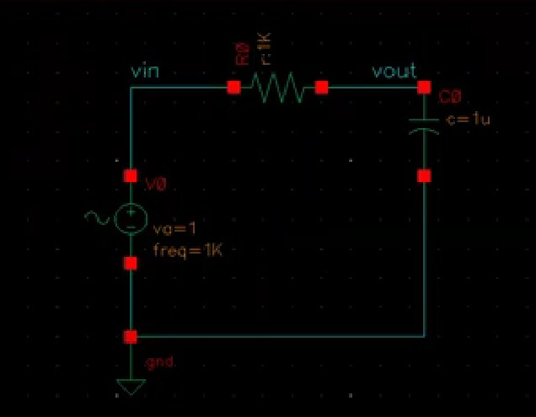

Figure 1: Low Pass Filter

# CHAPTER 3: DESIGN AND IMPLEMENTATION

#### Design Process Overview

##### Specifications Definition

**Locking Time:** Define the maximum time allowed for the PLL to lock onto the reference frequency.

**Jitter:** Specify acceptable levels of timing variation in the output signal.

**Phase Noise:** Quantify the noise performance in terms of dBc/Hz at specific offset frequencies.

**Power Consumption:** Provide target values for overall power efficiency to ensure suitability for low-frequency applications.

##### Simulation Flow

**Schematic Design:** Tools and methodologies used for designing component schematics, such as Cadence Virtuoso or LTspice.

**Transient Analysis:** Steps for analyzing time-domain behavior to evaluate the dynamic response of the design.

**Performance Evaluation:** Outline procedures for measuring critical parameters such as phase error, noise, and power consumption.

|  |  |
| --- | --- |
| **Component/ Process** | **Details** |
| **Objective** | Design and simulate the combined **Phase Frequency Detector (PFD)** and **Charge Pump** using 180nm CMOS technology  for a PLL system. |
| **Software Tools Used** | Cadence Virtuoso (schematic design,  layout, and simulation). |
| **Technology Node** | 180nm CMOS technology. |
| **Design Steps** |  |
| 1. **PFD Design** | - Use **D flip-flops**, **NAND gates**, and a  **reset circuit** to create the PFD. |
|  | - **Inputs**: Reference clock (ref) and  feedback clock (vco). |
|  | - **Outputs**: UP and DOWN signals, indicating phase differences. |
|  | - Use 180nm CMOS standard library  cells for gates and flip-flops. |

|  |  |
| --- | --- |
|  | - Ensure proper reset mechanism to avoid  deadlock or meta stability. |
| 2. **Charge Pump Design** | - Implement **current sources/sinks** using  **PMOS and NMOS transistors.** |
|  | - **Inputs**: UP and DOWN signals from  PFD. |
|  | - Add a **switching circuit** to control current flow based on UP and DOWN  signals. |
|  | - Include **biasing circuitry** for stable current output. |
|  | - Add an optional **capacitor** at the output  to smooth the voltage for transient simulations. |
| 3. **Integration** | -Connect the UP and DOWN outputs from the  PFD to the input gates of the Charge Pump transistors. |
|  | - Ensure proper **signal compatibility** between  PFD and Charge Pump. |
|  | - Run preliminary transient simulations to verify connections and response. |
| **Simulation Steps** |  |
| 1. **Input Signals** | - Apply two clock signals: |
|  | - ref (e.g, 1MHz, fixed duty cycle, constant frequency). |
|  | - vco (e.g., 0.9MHz–1.1MHz, varying frequency or phase offset). |
| 2. **Transient Analysis** | - Perform a transient analysis over 50ns–100ns. – Observe **UP, DOWN**, and **charge pump**  **output voltage**. |
|  | - Check phase-leading and phase-lagging scenarios by varying the VCO input phase. |
| 3. **Waveform Observation** | - **Waveform 1**: Reference clock (ref). |
|  | - **Waveform 2**: Feedback clock (vco). |
|  | - **Waveform 3**: UP and DOWN signals  generated by the PFD. |
|  | - **Waveform 4**: Charge Pump output voltage  (smooth and stable response). |
| **Key Design Parameters** |  |
| - **Technology Node** | 180nm CMOS technology. |
| - **Supply Voltage** | 1.8V (typical for 180nm processes). |
| - **Clock Frequency** | Test frequencies between 1MHz and 10MHz  for accurate response. |
| - **Transistor Dimensions** | PMOS/NMOS: Use W/L ratios typical for |

|  |  |
| --- | --- |
|  | 180nm technology (e.g., 10/1 for NMOS, 20/1  for PMOS). |
| - **Current Sources** | Design charge pump current source for typical  values like 10µA or 100µA. |
| **Verification Metrics** |  |
| - **Correct Functionality** | PFD generates UP and DOWN signals for  phase-leading and lagging inputs. |
| - **Output Voltage** | Charge pump output stabilizes at the expected voltage for different phase differences. |
| - **Reset Mechanism** | PFD properly resets when phase difference  reduces to zero. |
| - **Power Consumption** | Analyze power usage during simulation and optimize if necessary. |

**Table 1: Design and Simulation Steps for PFD and Charge Pump in 180nm CMOS Technology.**

#### Design of Phase Frequency Detector (PFD)

##### Circuit Description

Schematic: Present the PFD circuit diagram designed with D flip-flops and reset logic for phase detection.

Operational Principle: Explain how the PFD generates "up" and "down" signals based on phase and frequency differences between input signals. Highlight the role of reset logic in avoiding dead zones.

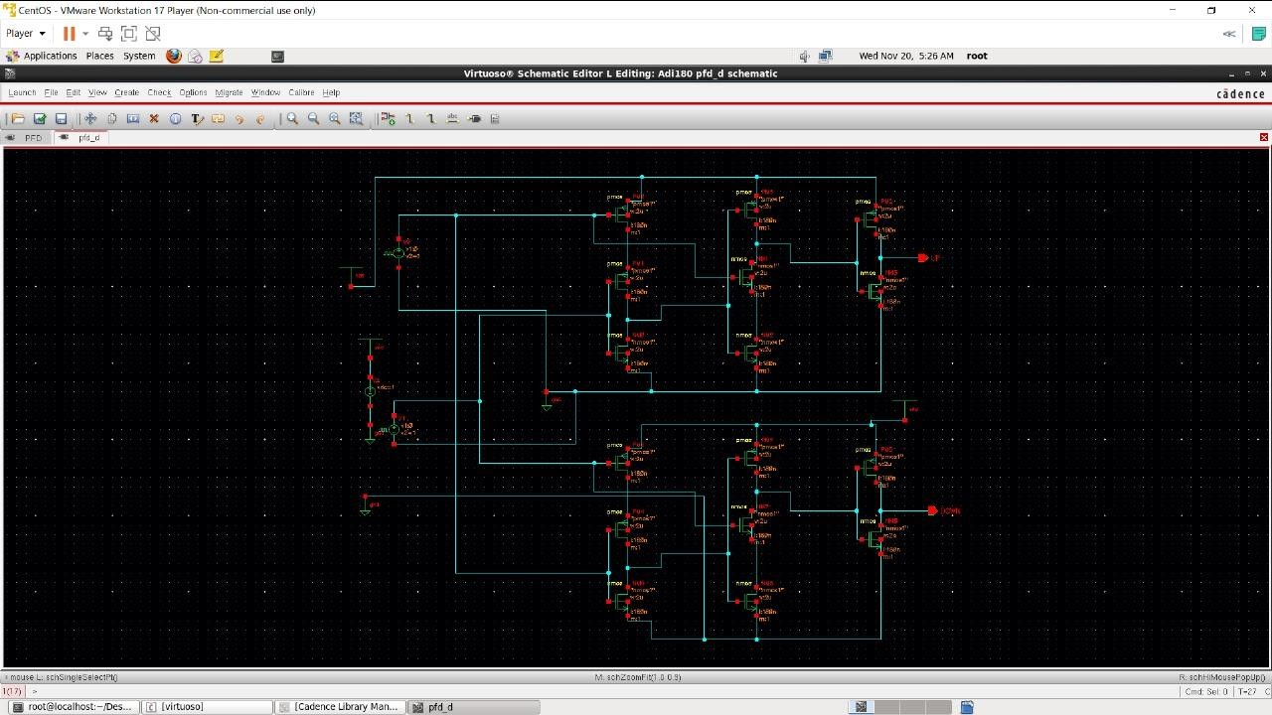

Figure 2: Schematic of PFD

Figure 2 shows the schematic of a Phase Frequency Detector (PFD) designed in Cadence Virtuoso. The PFD compares two input signals, typically the reference clock (Ref) and the feedback clock (Fb), to detect phase differences. The output signals, UP and DN, are generated based on this comparison and control the charge pump and VCO in a Phase- Locked Loop (PLL).

The design uses both PMOS and NMOS transistors to implement XOR gates, which produce pulses proportional to the phase difference. These pulses help adjust the VCO's frequency to reduce phase error and synchronize the PLL.

This schematic is a key component in PLL systems, ensuring accurate frequency and phase alignment between the reference and feedback signals.

##### Simulation Flow

Phase Error Analysis: Graphs showing phase error detection for varying input conditions. Speed Evaluation: Analysis of PFD response time, ensuring it meets low-frequency design requirements.

Power Consumption: Measure energy efficiency of the circuit, confirming its suitability for CMOS technology.

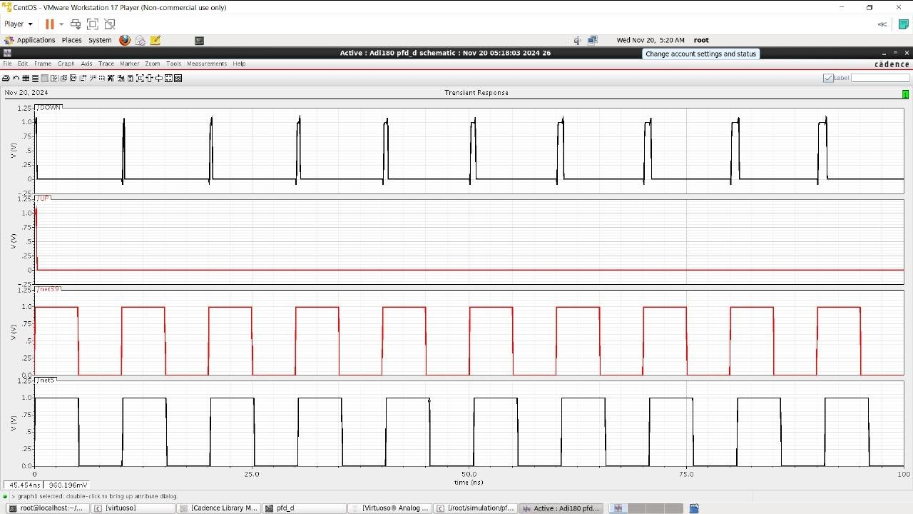

Figure 3: Simulation of PFD

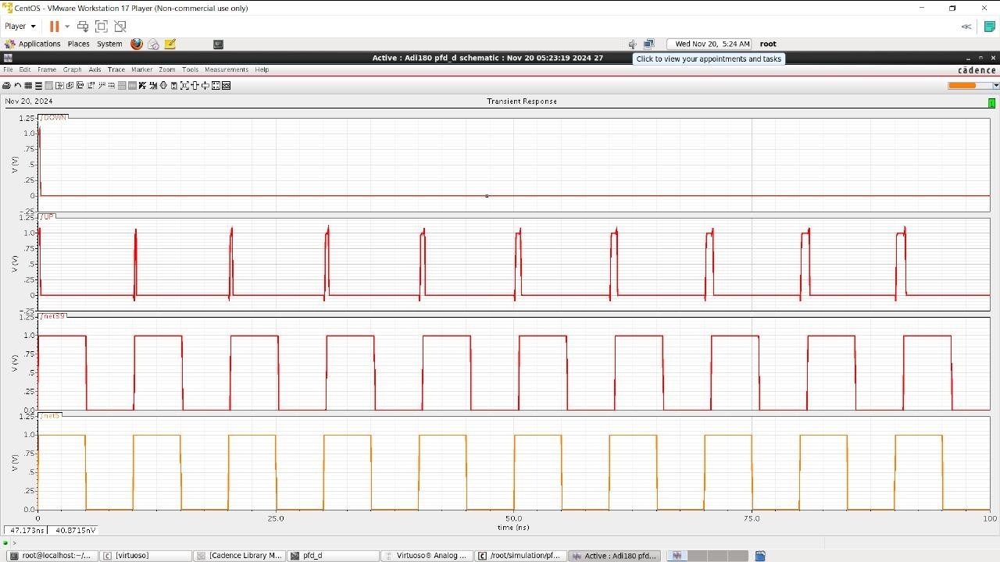

Figure 4: PFD’s Simulation result

Figure: 3 and 4 demonstrates the transient response of the Phase Frequency Detector (PFD), a key component of the Phase-Locked Loop (PLL). The simulation showcases the behavior of the PFD inputs, namely the reference clock and the feedback clock, and their corresponding outputs. The PFD identifies the phase and frequency differences between the two input signals, producing UP and DOWN control signals. These signals are then fed into the charge pump to adjust the control voltage of the Voltage- Controlled Oscillator (VCO). The timing characteristics of the waveforms confirm proper detection and control signal generation, ensuring accurate phase alignment

#### Design of Charge Pump (CP)

##### Circuit Description

Schematic: Present the designed CP circuit, including current sources, switches, and capacitors.

Operation: Describe how the CP translates "up" and "down" signals from the PFD into control voltages for the VCO. Include details on minimizing current mismatch and ensuring efficient charge transfer.

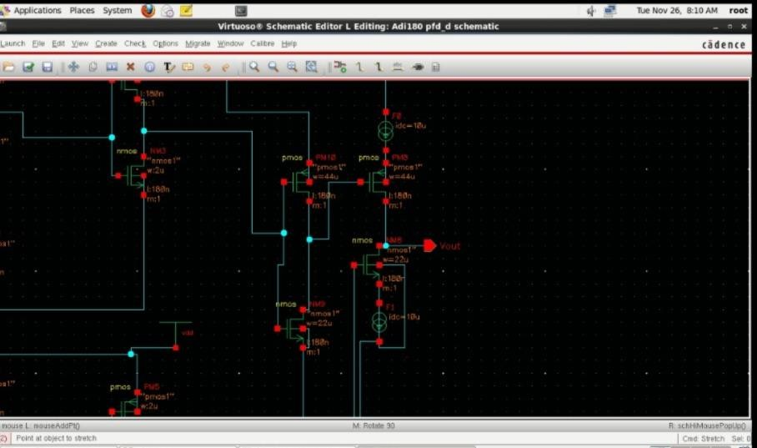

Figure 5: Schematic of Charge Pump

Figure: 5 provides the detailed schematic of the charge pump circuit, an integral component of the PLL system. The circuit is composed of PMOS and NMOS transistors arranged in a complementary fashion to allow bidirectional current flow. The UP and DOWN signals from the PFD control the activation of the PMOS and NMOS switches, enabling the circuit to either source or sink current to the loop filter. This design ensures precise voltage adjustments to control the VCO frequency. Proper biasing is implemented to stabilize the circuit and minimize switching noise, contributing to the PLL's overall performance.

##### Simulation Flow

Current Mismatch: Graphs showing the accuracy of current matching during operation. Settling Time: Evaluate the time taken for the CP to stabilize after a phase or frequency error is introduced.

Noise Analysis: Simulate the noise performance of the CP to ensure it aligns with low- frequency requirements.

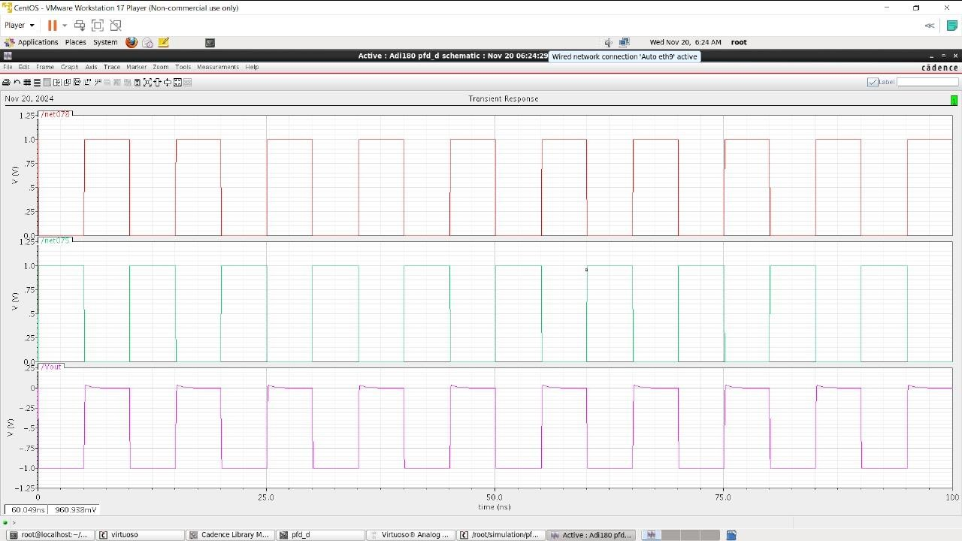

Figure 6: Ideal Output for Charge Pump

Figure: 6 illustrates the ideal output waveforms of the charge pump under simulation. The output voltage demonstrates a well-regulated response to the UP and DOWN control signals. This indicates that the charge pump is effectively translating the PFD's control signals into precise current adjustments for the loop filter. The ideal waveform ensures that the voltage output remains within the desired operating range, contributing to the smooth operation of the PLL. The linear and steady nature of the waveforms confirms the circuit’s reliability in handling phase and frequency corrections.

#### Integration PFD and CP

##### Combined Schematic

Provide a circuit diagram showing how the PFD and CP are connected in the PLL system. Highlight signal flow and the interdependencies between the two components.

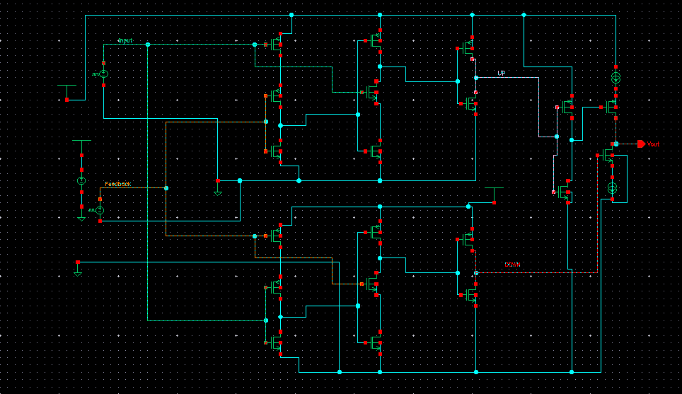

Figure 7: Integrated Schematic of PFD and CP

The schematic shown in Figure 7 represents the combined implementation of the Phase Frequency Detector (PFD) and Charge Pump designed in Cadence Virtuoso. The PFD is responsible for detecting the phase and frequency difference between two input signals (ref and vco) and generating control signals (UP and DOWN). These signals drive the charge pump, which adjusts the control voltage applied to the Voltage-Controlled Oscillator (VCO) in the Phase-Locked Loop (PLL) system.

Key features of the schematic:

* + - * PFD Circuit Design: Implements logic gates and flip-flops to produce accurate UP and DOWN signals based on input phase differences.
      * Charge Pump Design: Converts the digital control signals into a corresponding analog control voltage by sourcing or sinking current, depending on the UP and DOWN signal states.
      * Integrated Layout: The combined circuit ensures smooth interaction between the PFD and charge pump, facilitating precise phase and frequency locking.

##### Simulation Analysis

Phase Error Correction: Show simulation results demonstrating the combined PFD-CP performance in detecting and correcting phase errors.

Control Signal Stability: Graphs illustrating the stability and smoothness of the CP

output signal over time.

Dynamic Response: Evaluate the response of the integrated system to changes in input conditions, ensuring robust and reliable operation.

##### Simulation Results

.

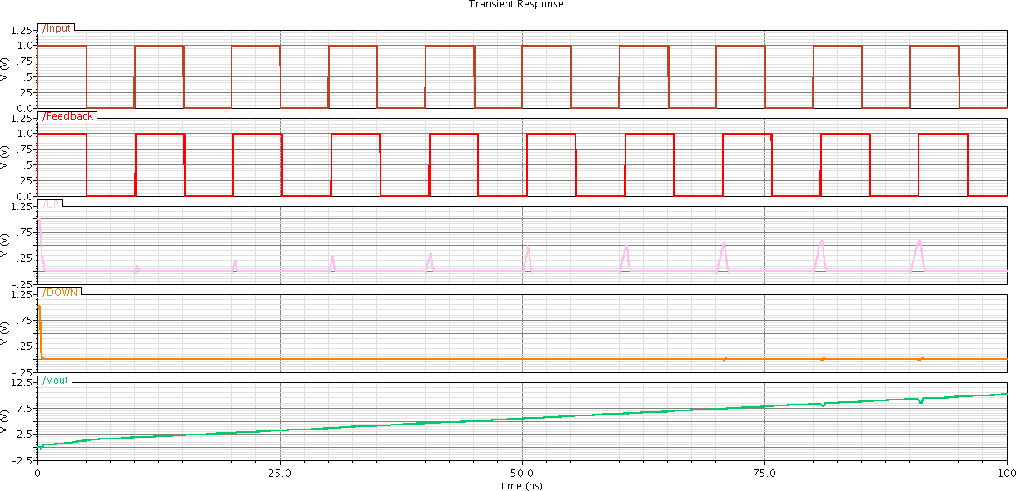

Figure 8: Transient Response when Input Signal is Lagging



Figure 9: Transient Response When both signal are same

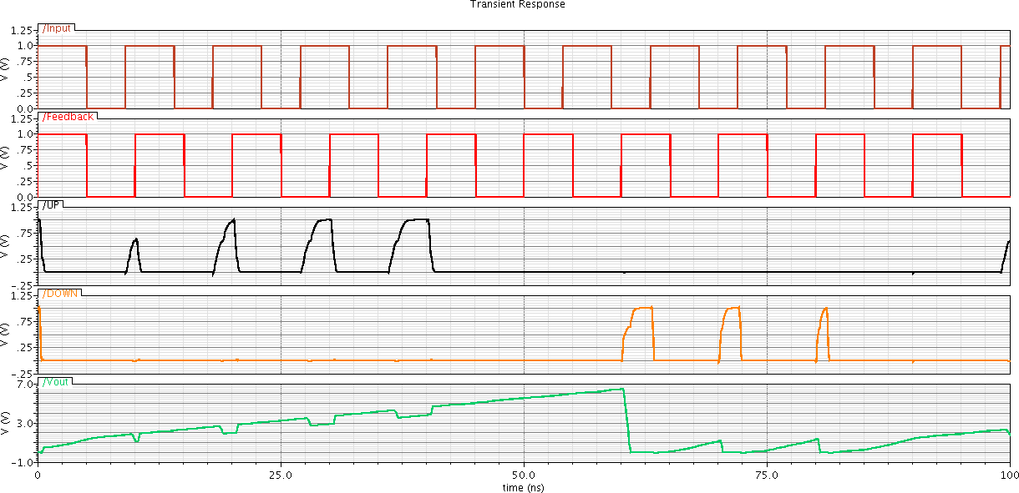

Figure 10: Transient Response when Input signal is Leadingssss

The simulation results displayed in Figure 8, 9, 10 demonstrate the simulation response of the combined PFD and Charge Pump circuit:

Input Signals: The top two waveforms represent the reference clock signal (ref) and the VCO feedback signal (vco). These signals are inputs to the PFD.

Control Signals: The third waveform illustrates the UP and DOWN signals generated by the PFD, which reflect the phase difference between ref and VCO.

Charge Pump Output: The last waveform represents the output voltage of the charge pump. The output varies in response to the control signals, driving the feedback loop of the PLL.

The results confirm the correct functionality of the circuit. The PFD accurately generates the UP and DOWN signals based on the phase difference between the input signals, and the charge pump effectively produces the expected analog output. This combined system is a critical component in the PLL, ensuring precise synchronization between the reference and feedback signals.

# CHAPTER 4: SIMULATION AND RESULTS

#### Simulation Setup

##### Tools Used

Cadence Virtuoso: For schematic entry and SPICE-level simulations.

LTspice: Alternative for simulating component behavior and system-level interactions. Simulation Environment: Briefly describe the computing environment, including tool versions and design libraries used.

##### Test Conditions

Voltage Levels: Define the supply voltage range (e.g., 1.2V for low-power CMOS designs).

Input Frequencies: Specify the range of input reference frequencies used for testing. Load Conditions: Include details about simulated load conditions and any parasitic elements considered.

Initial Conditions: Mention initial states (e.g., initial phase difference set to zero or a specific offset).

#### PFD Simulation Analysis

##### Performance Metrics

Locking Time: Measure the time taken by the PFD to stabilize phase detection. Speed: Evaluate the maximum frequency range the PFD can handle.

Accuracy: Analyze the ability to detect phase and frequency mismatches without dead zones.

##### Graphical Results

Timing Diagrams: Include waveforms for the "up" and "down" signals during typical and edge-case scenarios.

Phase Error Graphs: Plot the phase error against time to demonstrate the PFD’s precision and response to changes.

#### CP Simulation Analysis

##### Performance Metrics

Current Mismatch: Quantify the difference between sourcing and sinking currents in the charge pump.

Transient Response: Measure the time required for the CP to stabilize after phase corrections.

Noise Characteristics: Analyze noise at the output of the CP to ensure it remains within acceptable limits for low-frequency applications

##### Graphical Results

Key Waveforms: Display the voltage and current waveforms at critical nodes in the CP. Statistical Data: Include histograms or tables summarizing current mismatch percentages and noise levels.

#### Integrated PLL Simulation

##### Locking Performance

Locking Time: Simulate and report the time required for the PLL to lock onto the reference frequency across different conditions.

Frequency Stability: Provide graphs showing output frequency over time as the system reaches steady-state operation.

##### Phase Noise and Jitter

Phase Noise: Include phase noise plots (e.g., dBc/Hz vs. offset frequency) to evaluate spectral purity.

Jitter: Present statistical analysis of timing jitter, including peak-to-peak and RMS jitter values.

##### Graphical Results

Integrated Waveforms: Show combined input and output waveforms of the PLL to highlight synchronization and stability.

Control Voltage Dynamics: Plot the control voltage variation during the locking process.

# CHAPTER 5: CHALLENGES AND OPTIMIZTION

#### Challenges in Low-Frequency PLL Design

##### Component-Specific Challenges

**PFD Dead Zone:**

Issue: Conventional PFD designs, especially XOR-based configurations, suffer from dead zones where phase detection fails.

Impact: Dead zones lead to poor phase synchronization, affecting the PLL's locking accuracy.

##### Charge Pump (CP) Current Mismatch:

Issue: Differences in sourcing and sinking currents cause phase offset and degrade the linearity of the control signal.

Impact: Current mismatch results in increased jitter and reduces overall stability.

##### Voltage-Controlled Oscillator (VCO) Noise:

Issue: The VCO is a major source of phase noise in the PLL. Low-frequency designs are particularly susceptible to flicker noise (1/f noise).

Impact: High noise levels affect output signal purity, limiting the PLL’s application in precision systems.

##### System-Level Challenges Stability Concerns:

Issue: Achieving a stable feedback loop is challenging due to the sensitivity of low-

frequency designs to component variations.

Impact: Instability manifests as overshoot, prolonged locking time, or oscillatory behavior in the control loop.

##### Integration Complexity:

Issue: Integrating multiple components like PFD, CP, VCO, and loop filters on a single CMOS chip introduces parasitic effects.

Impact: Parasitics can lead to performance degradation and increased power consumption.

##### Noise Immunity:

Issue: Low-frequency PLLs are particularly vulnerable to external and internal noise sources.

Impact: Noise affects signal fidelity, leading to phase jitter and frequency deviation.

#### Proposed Optimizations

##### Circuit Level Improvements PFD Dead Zone Elimination:

Solution: Use D flip-flop-based tri-state PFDs to eliminate dead zones and improve phase detection accuracy.

Impact: Enhances the PLL’s ability to lock onto the input signal quickly and accurately.

##### CP Current Mismatch Reduction:

Solution: Introduce cascode current mirrors in the CP design to minimize current mismatches.

Alternative: Use a feedback-based charge pump to dynamically adjust currents for better matching.

Impact: Reduces jitter and ensures a more linear control voltage for the VCO.

##### VCO Noise Reduction:

Solution: Implement a differential ring oscillator or add noise filtering circuits to suppress flicker noise.

Alternative: Use LC-based oscillators with high-quality factor (Q) inductors to achieve lower phase noise.

Impact: Improves spectral purity and output signal stability.

##### System Level Enhancements Loop Filter Optimization:

Solution: Design an active loop filter with adjustable bandwidth to balance noise rejection and dynamic response.

Alternative: Use higher-order filters to achieve better noise suppression without compromising stability.

Impact: Enhances the system’s ability to filter out high-frequency noise, reducing phase jitter.

##### Improved System Architecture:

Solution: Implement adaptive loop gain control to maintain stability across a wide range of operating conditions.

Alternative: Utilize digitally assisted PLL architectures for better precision and programmability.

Impact: Improves overall robustness and scalability of the PLL design.

# CHAPTER 6: APPLICATION AND FUTURE SCOPE

#### Applications of Low-Frequency PLLs

##### Communication Systems

Frequency Synthesis: Low-frequency PLLs play a critical role in generating stable clock signals and synthesizing frequencies for wireless communication systems.

Application: Cellular networks, Bluetooth, and Wi-Fi devices.

Clock Recovery: PLLs are widely used to extract timing information from data streams in serial communication protocols.

Example: USB, Ethernet, and SPI interfaces.

##### Audio Processing

Stable Frequency Generation: PLLs provide precise frequency control for audio applications, ensuring low jitter and distortion-free signals.

Application: Audio DACs, amplifiers, and musical instruments.

Noise Suppression: Used to filter out unwanted frequency components in audio systems, enhancing sound quality.

##### Industrial Control

Precise Frequency Control: PLLs are vital for motor speed control, robotics, and automation where accurate frequency generation is essential.

Application: Factory automation, CNC machines, and power systems.

Signal Synchronization: Enable synchronization between multiple devices in industrial communication networks.

#### Future Scope

##### Advanced CMOS Technologies

Improved Performance: With the adoption of advanced CMOS nodes (e.g., FinFETs, FDSOI), PLLs can achieve lower power consumption, reduced noise, and higher speeds. Potential: Scaled designs for energy-efficient applications.

Miniaturization: New fabrication techniques can lead to compact, low-frequency PLL designs suitable for integration in portable devices.

##### Integration with Emerging Technologies

IoT and Edge Computing: Low-frequency PLLs can provide precise timing control for sensors and edge devices, enabling efficient data synchronization.

Example: Smart homes, wearable devices, and industrial IoT.

AI-Driven Systems: PLLs can be integrated into AI accelerators to ensure stable clocking for high-precision computations.

Application: Neural networks, autonomous vehicles, and robotics.

##### Extension to Other Frequencies

Mid- and High-Frequency Adaptations: The techniques developed for low-frequency PLLs can be modified for use in mid- and high-frequency systems.

Potential: Applications in satellite communications, radar systems, and GHz-level processors.

Wide-Band PLL Designs: Future PLLs may adapt to dynamically switch between low, mid, and high-frequency ranges for versatile use.

# CHAPTER 7: CONCLUSIONS

This study focused on the design, simulation, and optimization of a CMOS-based low- frequency Phase-Locked Loop (PLL), addressing key challenges such as phase noise, jitter, and system stability. By improving the Phase Frequency Detector (PFD) with a D-flip-flop-based design and optimizing the Charge Pump (CP) for reduced current mismatch, the PLL achieved enhanced locking performance and noise suppression. The integration of these components, along with a carefully designed loop filter, demonstrated stable and efficient operation suitable for various applications in communication, audio processing, and industrial control.

Overall, this work provides valuable insights into the design methodologies for low-frequency PLLs and highlights their scalability to emerging technologies like IoT and AI. The proposed optimizations offer a strong foundation for future research, enabling advancements in PLL performance across broader frequency ranges and evolving technological landscapes. These findings emphasize the significance of achieving a harmonious balance between performance, power efficiency, and scalability, paving the way for innovative PLL designs that meet the stringent demands of next-generation systems. Future efforts can build upon this framework to explore higher-frequency applications, improved integration techniques, and adaptive PLL architectures tailored to dynamic and complex environments. Additionally, this study underscores the potential for CMOS-based PLLs to enhance system-level integration, supporting the seamless convergence of communication, computation, and control systems.

## REFERENCES

1. F. M. Gardner, "Charge-Pump Phase-Lock Loops," IEEE Transactions on Communications, vol. 28, no. 11, pp. 1849–1858, Nov. 1980.
2. Z. Huang and H. Song, "Low-Power and High-Speed Phase Frequency Detector and Charge Pump for PLL Applications," in Proc. IEEE International Symposium on Circuits and Systems (ISCAS), May 2016, pp. 247–250.
3. S. Kiaei and A. Abbasfar, "A New Phase Frequency Detector for Fast PLL Acquisition," in Proc. IEEE International Conference on Electronics, Circuits, and Systems (ICECS), Dec. 2004, pp. 83–86.
4. K. S. Kundert and C. Chang, "Simulation and Analysis of Phase-Locked Loops," in Proc. IEEE Custom Integrated Circuits Conference (CICC), Sep. 2005, pp. 213–216.
5. S. Pavan, Y. Tsividis, and B. A. Wooley, "High-Performance CMOS Phase-Locked Loops Design Techniques," IEEE Journal of Solid-State Circuits, vol. 35, no. 8, pp. 1138–1148, Aug. 2000.
6. B. Rhee, "Design of a Low-Jitter PLL with Improved Charge Pump Linearity," IEEE Transactions on Circuits and Systems I: Regular Papers, vol. 51, no. 1, pp. 1–9, Jan. 2004.
7. K. Lim, J. Choi, and B. Kim, "A Low-Jitter and Low-Phase Noise PLL With a Current-Matching Charge Pump," IEEE Transactions on Circuits and Systems II: Analog and Digital Signal Processing, vol. 48, no. 3, pp. 311–317, Mar. 2001.
8. M. Mansuri, D. Liu, and C. K. Yang, "Fast Frequency Acquisition Phase-Frequency Detectors for GSamples/s Phase-Locked Loops," IEEE Journal of Solid-State Circuits, vol. 37, no. 10, pp. 1331–1334, Oct. 2002.
9. J. Lee and M. S. Kim, "A Fully Integrated Low-Power CMOS PLL for Ultra- Wideband Applications," IEEE Transactions on Microwave Theory and Techniques, vol. 54, no. 3, pp. 1385–1393, Mar. 2006.
10. M. Dai, M. Ismail, and H. Olsson, "CMOS Phase-Locked Loops for Wireless Communications: A Tutorial," IEEE Communications Magazine, vol. 36, no. 12, pp. 134–144, Dec. 1998.
11. J. C. Rudell, J. Ou, and T. H. Lee, "A 1.9-GHz Wide-Band IF Double Conversion CMOS Receiver for Cordless Telephone Applications," IEEE Journal of Solid-State Circuits, vol. 32, no. 12, pp. 2071–2088, Dec. 1997.
12. K. Kim and W. Lee, "A High-Speed, Low-Power Phase-Frequency Detector for High- Performance PLLs," in Proc. IEEE International Symposium on VLSI Design, Automation and Test (VLSI-DAT), Apr. 2013, pp. 152–155.
13. J. Yuan and C. Svensson, "High-Speed CMOS Circuit Technique," IEEE Journal of Solid-State Circuits, vol. 24, no. 1, pp. 62–70, Feb. 1989.
14. S. Jang and C. Kim, "A Novel Charge Pump with Low Current Mismatch for PLL Applications," in Proc. IEEE Asian Solid-State Circuits Conference (A-SSCC), Nov. 2015, pp. 105–108.
15. W. Rhee, "Design of High-Performance CMOS Charge Pumps in Phase-Locked Loops," in Proc. IEEE International Symposium on Circuits and Systems (ISCAS), May 1999, pp. 545–548.
16. H. Pan and L. X. Zhen, "Design and Optimization of a Phase Frequency Detector and Charge Pump for Low-Jitter PLLs," IEEE Access, vol. 7, pp. 4550–4559, Jan. 2019.